Part-Time Job Opportunity Information
2020
Seeking the following positions for summer 2020
Recreation Leaders ll
Swim Instructors/Recreation Leaders
Inclusion Support Leaders
Swim Instructors (Pool)
“With Antigonish, For Antigonish”

TABLE OF CONTENTS
Important Information
Recreation Employment Opportunities & Hiring Procedures | Page 3
Overview of Recruitment & Selection Process | Page 3
Application Process | Page 4
Application Package Checklist | Page 5
Background Checks | Page 5
Job Descriptions
Recreation Leader II | 16
Swim Instructor | 18
Swim Instructor & Recreation Leader | 20
Inclusion Support Leader | 22
Appendices
Appendix A – Application Form
Or visit: https://recreation.antigonishcounty.ns.ca/employment

Recreation Employment Opportunities & Hiring Procedures
Interesting job opportunities await you at Antigonish County Recreation (a department of the Municipality of the County of Antigonish). Each job has a specific list of qualifications, but in general we are looking for the following skills and attributes, also known as competencies:
- A focus upon community and customer service.
- A responsible and positive attitude.
- The ability to take initiative, maintain positive attitude & high energy.
- Effective communication skills and the ability to work well with others
- Leadership and the ability to motivate the group for best results.
- A focus on working safely and collaboratively.

The most qualified candidate fills all vacant positions. In recruiting, selecting and hiring candidates, the principles of merit and fairness are maintained. All former employees must re-apply, and must complete the application form the application form at the back of this booklet. Those reapplying are to indicate the currency of their qualifications for the position as described. Employees currently employed by Antigonish County Recreation in another capacity must also complete the application if they wish to be considered for positions outlined in this booklet.
The number of jobs available annually may vary, and is dependent upon a variety of elements including: budget approval; grant funding, and program registration numbers. Employment dates listed in this booklet are approximate and subject to change, based on what is best for the program and community.
If you are offered a position you must have a Social Insurance Number (SIN) in order to be paid. If you do not already have a Social Insurance Number (SIN number) you should contact Human Resources Development Canada as soon as possible to obtain this number.
If you are contacted for an interview, please bring your proof of certifications to your job interview.
Overview of Recruitment & Selection Process
The interview process helps us evaluate your qualifications and experience, as well as to assess your leadership, motivation, and communication/interpersonal skills and how well you meet the core competency (key skill) requirements. As a potential candidate, your objective is to convey a good sense of who you are, what you have to offer (your skills, knowledge, certifications, experience, education) as well as to discover if the position matches your values, interests and skills.
Our behavioural-based interview is one where skills are assessed based on previous behaviour in recent, similar situations. This type of interview typically asks candidates to describe a situation, then describe the actions you took in the situation, and detail the results of the actions taken. Candidates are required to bring copies of their résumé and certifications and references (if required) to the interview.
Application Process
STEP 1
Read the job descriptions and decide which job(s) you are interested in AND qualified for. Consider the requirements for each position and how you will meet the performance expectations. Ensure before submitting the application you are committed to enjoying the role with Antigonish County Recreation (ACR) and contributing in a meaningful way to the team and community.
STEP 2
Complete your Application Package. Please specify the position(s) you are applying for, clearly indicating your order of preference. An application form can be found at the end of this document (Appendix A) or online at recreation.antigonishcounty.ns.ca. Please see checklist for a comprehensive list of what to include for a successful application package.
STEP 3
Submit your unique application package in one of the following ways:
EMAIL: recreation@antigonishcounty.ns.ca
IN PERSON: Municipal Building, 285 Beech Hill Road, Antigonish County
MAIL: 285 Beech Hill Road
FAX: 902-863-5751
STEP 4
Those who best meet the required skills and qualifications for the position(s) will be invited to an interview. Invitations will be sent and confirmed by email. The ACR recruitment committee member will schedule an interview at a time that is convenient for you. If you do not get a call it means you did not make it to the interview stage, but don’t be discouraged. The department receives many strong applications every year so there is a lot of competition. Please apply again in the future.
STEP 5
Attend your interview.

STEP 6
You will be contacted by an ACR recruitment committee member whether they plan to offer you a position or not. If you are offered a position, you take this opportunity to either accept or decline the opportunity. If you do not get an offer, we thank you for your interest and encourage you to apply again in the future.
STEP 7
The ACR recruitment committee member will fill you in on next steps, like orientation, teambuilding, training, certifications, and more! They will also ask you to provide any necessary additional information, like background checks, to the office.
Application Package Checklist
- Completed application form*
- Up to date resume including three (3) references*

- Copies of any relevant certifications you currently hold
- Copies of any recent awards or achievements relevant to position(s) applied for
- Proof of any relevant volunteer or life experience relevant to application
*Required
Please note the application process is the same for both new applicants and current/previous staff who are reapplying. Even staff currently employed with a different program must re-apply for all additional positions. The interviewing process, however, may be adjusted slightly for returning/current staff as they are already known to the recruitment committee.
ALSO, please ensure that you apply to ALL of the positions you wish to be considered for, in order of preference as noted above. If you were not successful in obtaining one position you may be successful in obtaining another, but not if you do not specify interest.
Background Checks
All applicants selected for a position are required to obtain, and to submit, a complete up-to-date screening check by the date listed in the offer letter. These forms can be obtained by visiting your local police department where you live. There is typically a cost and a wait time for these forms, so do not delay. It is a condition of employment to have a completed and satisfactory Criminal Record Check including a Vulnerable Sector Check as well as Child Abuse Register Search.

RECREATION LEADER II
Employment Commitment: Year-round, part-time position for a variety of programming (After School Programs, Outdoor Recreation, Older Adult Programming, other as required). Hours will vary depending on staff member availability & program demands.
Reports to: Physical Activity Coordinator, Recreation Programmer, After School Program Coordinator and/or other Program Coordinators
Basic Requirements:
- Must be at least sixteen (16) years old and have access to daily transportation
- Must be able to supply clean Child Abuse Registry, Vulnerable Sector, and Criminal Record Checks
- Expected to be present at work for all scheduled shifts/days as outlined in job description
- Full participation in all assigned training, teambuilding events, staff meetings, special events, etc.
- Organizational skills and experience with planning/implementation
- Experience with children, youth, older adults
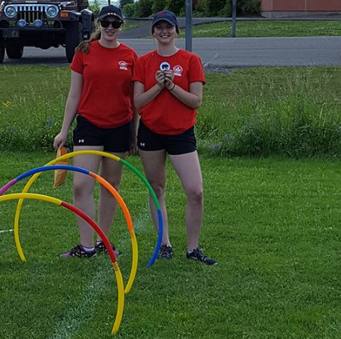
- To satisfy funding requirements, additional criteria may need to be met for some positions

Certification Requirements:
- Standard First Aid and CPR Level C or Equivalent
- HIGH FIVE Principles of Healthy Child Development
- WHMIS (Workplace Hazardous Materials Information Systems)
Prior completion of these certifications is an asset, but opportunities to achieve any missing certifications will be organized by the County for all successful applicants, completion mandatory to gain employment.

Position Summary
Core Competency | Position-Specific Task Descriptions
Leadership | - To oversee the delivery of recreation programs to ensure that a successful and professional program is being implemented  - To implement a curriculum for recreation programs which may include, but not limited to low organized games, physical activity, arts and crafts, drama, music, and outdoor recreation.  - Assist with organization of equipment and supplies, as well as preparation of activities.  - Treat all participants/customers with respect.  - Summer program leaders --To assist with Canada Day Celebrations and other special events as required.  - To adhere to policies outlined in the staff manual  - Various other duties as assigned by the Recreation Programmer or designate.
Safety & Risk Management | - To ensure that program areas are kept safe and free from hazards.  - Ensuring safety and risk management processes and policies are followed and applied.  - Supervise program participants during the course of the program
Program Management | - Adhere to all policies/procedures for implementation & complete any program related tasks as requested by Program Coordinators, Rec Programmer, PAC  - Organizing materials, cleaning up after activities, general logistics
Judgement | - Show the capacity to assess situations and act appropriately  - Make sound decisions based on the best interests of all parties involved
Teambuilding | - Full and active participation in all program activities, training sessions, and staff meetings as required.
Communications & Customer Service | - Responsible for daily duties, such as greeting participants, leading activities, ensuring the safety and enjoyment of participants  - Daily communication with participants, parents, public, superiors, etc.  - Use of age appropriate language and tone of voice, mindful of audience  - Completion of daily (and other) written reports as required
Problem Solving | - Determining and quickly implementing appropriate participant support and/or behaviour modification strategies as required  - Effectively manage & resolve day-to-day issues as they arise

INCLUSION SUPPORT LEADER
Employment Commitment:
- Late June to Mid-August
- 8 weeks @ 32 hours/week (Monday to Thursday)
- Dates are approximate and subject to change
Reports to: Summer Program Coordinator(s) & Recreation Programmer
Basic Requirements
- Must be at least sixteen (16) years old and have access to daily transportation
- Must have relevant training/experience supporting individuals with disabilities
- Ability and willingness to do person care considered an asset
- Must be able to supply clean Child Abuse Registry, Vulnerable Sector, and Criminal Record Checks
- Expected to be present at work for all scheduled shifts/days as outlined in job description
- Full participation in all assigned training, teambuilding events, staff meetings, special events, etc.
- To satisfy funding requirements, additional criteria may need to be met for some positions
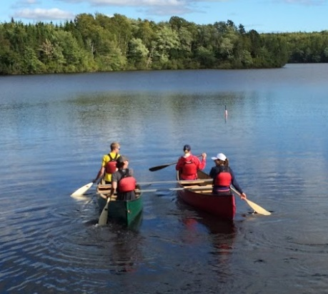
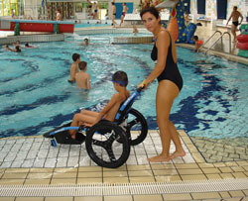
Certification Requirements
Program staff must have all required certifications listed below. Prior completion of these certifications is considered an asset, but opportunities to achieve any missing certifications will be provided by the County for all successful applicants.
- Standard First Aid and CPR Level C or Equivalent
- HIGH FIVE Principles of Healthy Child Development
- WHMIS (Workplace Hazardous Materials Information Systems)
Position Summary
Core Competency | Position-Specific Task Descriptions
Leadership | - Developing program inclusion strategies to create a successful program experience for inclusion participants, within County Recreation safety and resources requirements.  - Act as resource to day camp staff team members in terms of inclusive programming.  - Organizing equipment and supplies, preparing for activities.  - Treat all participants/customers with respect.  - To assist with Canada Day Celebrations and other special events as required  - To adhere to policies outlined in the staff manual. Various other duties as assigned by the Recreation Programmer, Physical Activity Coordinator and/or Recreation Director.
Safety & Risk Management | - To ensure that program areas are kept safe and free from hazards.  - Ensuring safety and risk management processes and policies are followed and applied.  - Supervise program participants during the course of the program
Program Management | - Adhere to all policies/procedures for implementation & complete any program related tasks as requested by Program Coordinators, Rec Programmer, PAC  - Organizing materials, cleaning up after activities, general logistics  - Communicating with families/guardians, using feedback to guide practices
Judgement | - Show the capacity to assess situations and act appropriately  - Make sound decisions based on the best interests of all parties involved
Teambuilding | - Full and active participation in all program activities, training sessions, and staff meetings as required.
Communications & Customer Service | - Providing one-on-one or one-on-two camper support to children with disabilities. The leader is caring, enthusiastic and patient and integrates program participants as much as possible into the daily program itinerary.  - Communicating regularly with participants and their families to support the effective participation of the children.  - Responsible for daily duties, such as greeting participants, leading activities, ensuring the safety and enjoyment of participants  - Completion of reports as required.
Problem Solving | - Determining and quickly implementing appropriate participant support and/or behaviour modification strategies as required  - Effectively manage & resolve day-to-day issues as they arise

SWIM INSTRUCTOR
Employment Commitment:
- First two weeks in July
- 2 weeks @ 16 hours/week, possibly more
- Monday - Thursday
Reports to: Aquatics and Summer Programs Coordinator and/or Recreation Programmer
Basic Requirements:
- Must be at least sixteen (16) years old and have access to daily transportation
- Must be able to supply clean Child Abuse Registry, Vulnerable Sector, and Criminal Record Checks
- Must be red-cross certified and have experience working with children and planning
- Expected to be present at work for all scheduled shifts/days as outlined in job description
- Full participation in all assigned training, teambuilding events, staff meetings, special events, etc.
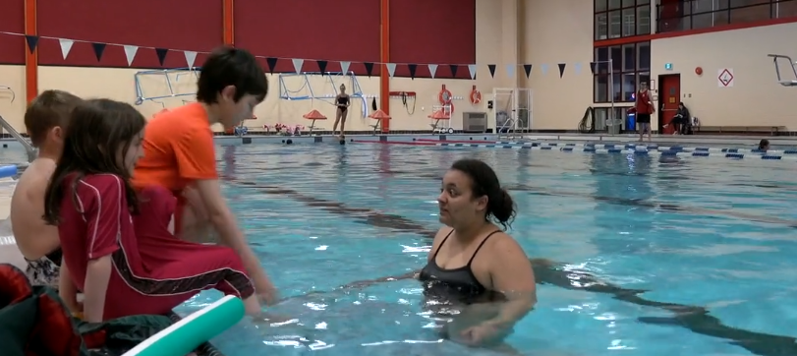
- To satisfy funding requirements, additional criteria may need to be met for some positions

Certification Requirements:
- Standard First Aid and CPR Level C or Equivalent
- HIGH FIVE Principles of Healthy Child Development
- WHMIS (Workplace Hazardous Materials Information Systems)
- Current Water Safety Instructor Certification
- Minimum Red Cross Water Safety Instructor Certification

Position Summary
Core Competency | Position-Specific Task Descriptions
Leadership | - To implement Red Cross Swimming Lessons and/or the Canadian Lifesaving program, depending upon the instructor’s qualifications.  - To teach and evaluate students enrolled in swim lessons as per the standards of the program as outlined by Red Cross and Royal Lifesaving Society.  - To prepare lesson plans for each class  - Organizing equipment and supplies, preparing for activities,  - Treat all participants/customers with respect.  - To assist with the implementation of water safety activities, Canada Day Celebrations and other special events as required.  - To adhere to policies outlined in the staff manual. Various other duties as assigned by the Recreation Programmer, Physical Activity Coordinator and/or Recreation Director
Safety & Risk Management | - To ensure that program areas are kept safe and free from hazards.  - Ensuring safety and risk management processes and policies are followed and applied.  - Supervise program participants during the course of the program
Program Management | - Adhere to all policies/procedures for implementation & complete any program related tasks as requested by Program Coordinators, Rec Programmer, PAC  - Organizing materials, cleaning up after activities, general logistics
Judgement | - Show the capacity to assess situations and act appropriately  - Make sound decisions based on the best interests of all parties involved
Teambuilding | - Full and active participation in all program activities, training sessions, and staff meetings as required
Communications & Customer Service | - Responsible for daily duties, such as greeting participants, leading activities, ensuring the safety and enjoyment of participants  - To complete administrative tasks as required (time sheets, worksheets, etc.)  - To complete and hand out progress memos and booklets on specified dates.  - Daily communication with participants, parents, public, superiors, etc.  - Use of age appropriate language and tone of voice, mindful of audience  - Completion of daily (and other) written reports as required
Problem Solving | - Determining and quickly implementing appropriate participant support and/or behaviour modification strategies as required  - Effectively manage & resolve day-to-day issues as they arise

SWIM INSTRUCTOR & RECREATION LEADER

Employment Commitment:
- Late June to mid-August
- 8 weeks @ 28-32hrs. /week
- Dates are approximate and subject to change
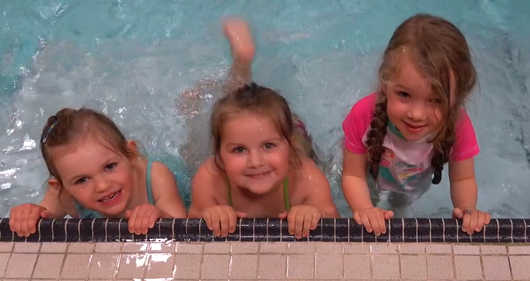
- In this position, successful candidates will work for 6 weeks as s Recreation Leader; and two additional weeks of split-days (half a day as a day camp leader and half the day swim instructor)
Reports to: Aquatics and Summer Programs Coordinator and/or Recreation Programmer
Basic Requirements:
- Must be at least sixteen (16) years old and have access to daily transportation
- Must be able to supply clean Child Abuse Registry, Vulnerable Sector, and Criminal Record Checks
- Expected to be present at work for all scheduled shifts/days as outlined in job description
- Full participation in all assigned training, teambuilding events, staff meetings, special events, etc.
- To satisfy funding requirements, additional criteria may need to be met for some positions
Certification Requirements:
- Standard First Aid and CPR Level C or Equivalent
- HIGH FIVE Principles of Healthy Child Development
- WHMIS (Workplace Hazardous Materials Information Systems)

Position Summary:
See summary for RECREATION LEADER job description
See summary SWIM INSTRUCTOR job description

APPLICATION FOR EMPLOYMENT
Please attach a resume along with application. Please print clearly and answer all questions.

Name:

Address:
Last Name First Name Initial

Street Number Rural Route #

City/County Province Postal Code

Contact Information:
Home Phone Cell Phone E-Mail

Have you previously been employed with Antigonish County Recreation? If yes, when? What Position(s)

Positions applied for: 1. (In order of preference) 2.
3.

SKILLS AND QUALIFICATIONS

Please summarize any applicable skills or qualifications for the position(s) in which you are applying:

RECREATION BACKGROUND or COMMUNITY EDUCATION BACKGROUND
Please summarize your background in Recreation, Sports, Hobbies, Special Interests, Extra Curricular Activities, Volunteer Work, etc.

EDUCATION BACKGROUND
 | NAME / LOCATION OF SCHOOL | GRADE/YEAR COMPLETED | DATE GRADUATED | DEGREE
HIGH SCHOOL
POST SECONDARY
OTHER
Do you have WHIMIS Training? Yes No Do you have Emergency First Aid & CPR? Yes No If yes, please include of copy certification(s).
(Successful candidates will be provided with WHIMIS and First Aid training opportunities if they do not hold certification)

I hereby confirm that all of the contents of this application are true and accurate, and I acknowledge that the Municipality of the County of Antigonish may verify each particular. I further authorize the release to the Municipality of the County of Antigonish of any information verifying the contents of this application, including the release by any relevant police authority of information concerning any record of offenses.

Signature of Applicant: Date:

